equity scan overview
  - School District No. 91 2019-2020

Introduction

During the 2018-2019 school year we took part in the Equity in Action Pilot Project which involved 16 other districts in the province. This Equity Scan was conducted in a family of schools model and stakeholder and rights holder representatives were invited from the community to collaborate with us and take part in the scanning process. The purpose of this was to understand the current context of Aboriginal Education within our communities in order to improve outcomes from Aboriginal Learners. The 4 pillars of Equity Scan are The Learning Profile, which we will look at data from, The Learning Environment, Policy and Governance and The Pedagogical Core. Our Superintendent of Schools for SD91, Manu Madhok, stated early in the process that this would be an opportunity to hold a mirror up to ourselves and be truly honest about what we see in our reflection. This sentiment is echoed in the 2015 Office of the Auditor General of BC’s Report on the education of Aboriginal Students in the B.C. public school system which stated that there is a ‘racism of low expectations for Aboriginal learners.’ In June 2019, an audit progress report was released and it was concluded that the ministry of education has made progress on all 11 of their recommendations, including four that it has been fully implemented. Another five are likely to be fully implemented once the ministry completes its actions currently underway and planned. With the final three recommendations, the ministry has taken some action but still has work to do.
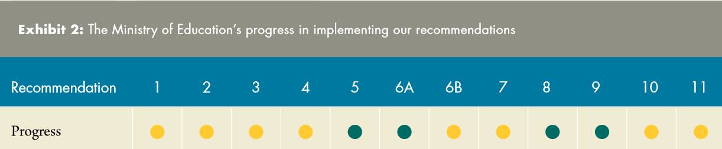
At the conclusion of the scanning process our family of schools equity scan groups from the LDSS, FLESS, NVSS and FSJSS developed a theory of change and also an action plan based on the outcomes of the 32 questions that were asked during the scanning process. In all communities there were three key areas that were identified as areas where growth is needed. It should be noted that in these areas there was consensus that a strong foundation exists. The areas were Culture and Language, Communication and Relationships. These are the areas that will guide the work of the School District 91.

Learning Profile Data for 2019-2020 Cohort Year

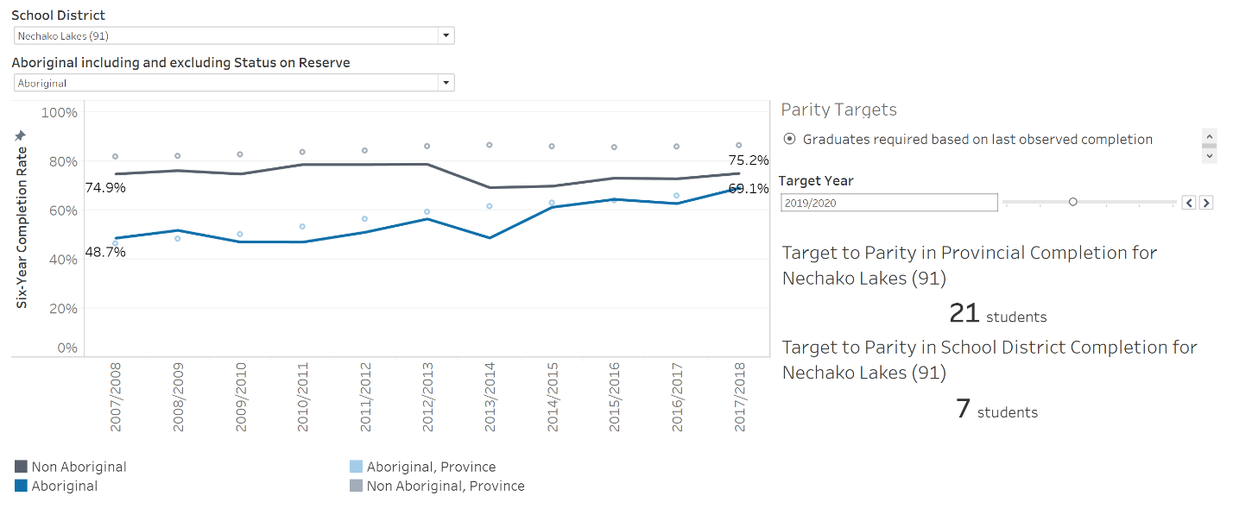
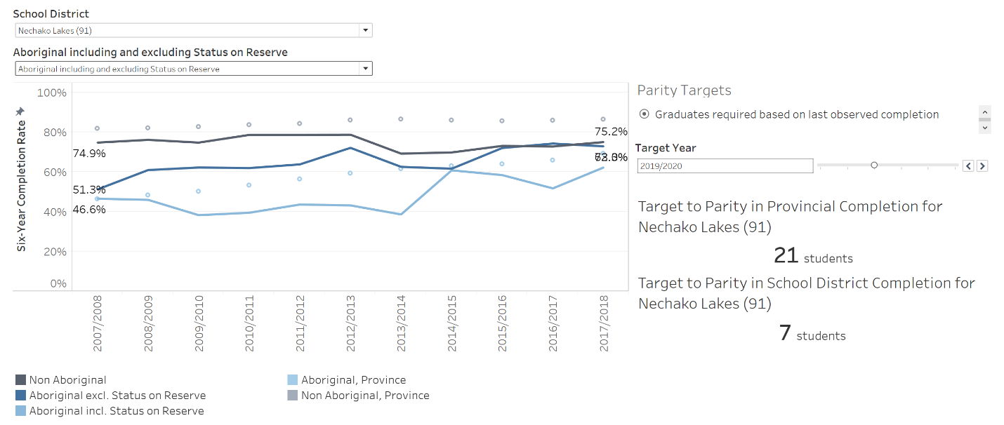

Theory of Change

“Together, we hold to the truth that our narrative must be transparent. We learn, in collaboration, from the land, culture and language of the local communities by communicating that learning with each other and building strong relationships.”
This statement will shift through the years as we achieve equity for Aboriginal learners in our system. This will happen as our target moves between equity to ensuring long-term success for our students. We will continue to strive to have our students graduate with dignity, purpose and options.

  - Action Plan: Key Programming Initiatives

Culture and Language (Honour Diversity)
- Increasing the number of Language Teachers throughout the district. The increase in funding for the 2019-2020 year was allocated to increase the number of teachers from 1.0 to 4.0 teachers throughout the district.
- It was identified that professional development of our staff was key to including Aboriginal Worldviews and Perspectives, our pedagogical core, throughout the curriculum. We are working on several district-wide programs and opportunities to address this gap including an annual Aboriginal Education conference, our AbEd Teacher Lead Program, our CUPE professional development day, 3-year Cultural Competency Training for our Administrators, an introductory Cultural Competency course for all existing and new employees, to start.
- We will be working with our nations on projects in order to increase language programming within our communities.

Connectedness and Relationship (Enhance Connections)
- It was identified in our scan that we need to build stronger relationships in several ways including those between teachers and parents, administrators and band leadership and also between our respective communities. In our district, we have a strong sense of collaboration and work with a very collaborative Aboriginal Education Committee. Through these relationships we hope to build on the foundations that exist and continue to work on parental engagement strategies, opportunities to work within communities and transparent relationships.

Communication (Enhance Connections)
- It is clear from the equity scan data that we have an issue with communication and this is creating a gap in knowledge between the public education system and the community. This year we are working to ensure that public is better informed of our programming and also is aware of our progress as we work on our goals. We have developed a communication strategy that combines regular news letters from the AbEd department, a website portal and utilizing social media.

  - Next Steps in Equity Scan 2019-2021

Student and Parent Voice Research, NOIIE Inquiry Team (Create Student Success and Honour Diversity)
- Last year, we completed research at LDSS, NVSS and FLESS. In an effort to understand some of the reasons that students are not transitioning through the grades we asked Grade 8 & 10 students at LDSS and FLESS and Grade 7 & 9 students at NVSS a series of questions.
- We worked with Dr. Dustin Louie to complete the research and are continuing to work with the raw data to report out and make recommendations to our system.
- Our AbEd Teacher Lead Cohort 1 group used this information to be the basis of our district-wide inquiry project. The Student and Parent voice results became one of the scanning tool used in the spiral of inquiry process through NOIIE. Through this team we are examining middle years students and thinking about ways to improve transitions.

Scanning within our System: Extending Research to Community (Enhance Connections and Engaging Our Workforce)
- This year, we are continuing the proposed research and examining the perspectives of school-based staff and First Nations Leadership. We have focused our work on LDSS which had the highest participation rate in the student and parent survey. Similarly, the Lake Babine Nation had the highest participation rate. We have approached the leadership of LDSS and will be meeting with the Lake Babine Nation to propose continuing this work with them.

Creating Opportunities that Result in Aboriginal students graduating with Dignity, Purpose and Options (Create Student Success)
- We have been working with the Career Department on scanning their programming to understand the opportunities available for Indigenous students. We will also be looking at ways to increase participation of Indigenous students.
- We are working with our nations on collecting and distributing scholarship, bursary and funding information to students.

